Problem statement:
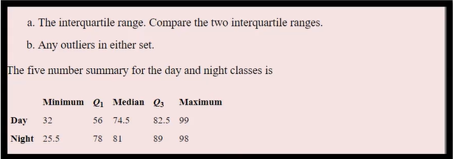

(a) IQR Calculation
Day Class
$$IQR=Q3-Q1=82.5-56=26.5$$
Night Class
$$IQR=89-78=11$$
Class | IQR
Day | 26.5
Night | 11

Comparison: The Day class has a larger IQR (26.5), so its scores are more spread out than those of the Night class, whose IQR is only 11.

(b) Detect Outliers
Day Class
Step 1: Lower Limit
$$56-(1.5×26.5) \\ 56-39.75 \\ =16.25$$
Step 2: Upper Limit
$$82.5+39.75 \\ =122.25$$
Compare with the given values:
- Minimum = 32
- Maximum = 99
Is 32 < 16.25?
No.
Is 99 > 122.25?
No.
Conclusion: There are no outliers in the Day class.

Night Class
Step 1: Lower Limit
$$78-(1.5×11) \\ 78-16.5 \\ =61.5$$
Step 2: Upper Limit
$$89+(1.5×11) \\ 89+16.5 \\ =105.5$$
Compare with the given values:
- Minimum = 25.5
- Maximum = 98
Is 25.5 < 61.5?
Yes.
So 25.5 is a lower outlier.
Is 98 > 105.5?
No.
So there is no upper outlier.

Outlier Analysis
Class | Lower Limit | Upper Limit | Minimum | Maximum | Result
Day | 16.25 | 122.25 | 32 | 99 | No outliers
Night | 61.5 | 105.5 | 25.5 | 98 | 25.5 is a lower outlier

